

RAJALAKSHMI INSTITUTE OF TECHNOLOGY
(An Autonomous Institution, Affiliated to Anna University, Chennai)

DEPARTMENT OF ARTIFICIAL INTELLIGENCE AND DATA SCIENCE ACADEMIC YEAR 2025 - 2026
SEMESTER III

ARTIFICIAL INTELLIGENCE LABORATORY MINI PROJECT REPORT

REGISTER NUMBER | 2117240070053
NAME | DEVESH A
PROJECT TITLE | Rock–Paper–Scissors: Frequency-Based Prediction with Counter- Strategy
DATE OF SUBMISSION | 29\10\2025
FACULTY IN-CHARGE | Mrs. M. Divya

Signature of Faculty In-charge

INTRODUCTION

This project is an advanced version of the Rock–Paper–Scissors game implemented using
Python. It integrates a modern graphical user interface (GUI) with Tkinter, a scoreboard, and a simple AI prediction system that learns from the player’s past moves. The project demonstrates key Artificial Intelligence concepts like pattern prediction, decision-making, and randomness in a fun and interactive way.

PROBLEM STATEMENT

To design and implement an interactive Rock–Paper–Scissors game using Python that allows continuous play, maintains a scoreboard, and applies a simple AI prediction model based on the user’s past moves, combined with randomness to make the computer’s responses intelligent and unpredictable.

THEORETICAL BACKGROUND

This project combines concepts from Artificial Intelligence and human-computer interaction. The random module provides unpredictability in computer decisions, while the AI logic predicts the player’s next move based on their previous choices. The Tkinter GUI offers a user-friendly interface with buttons, labels, and live score updates.
It demonstrates decision-making algorithms, pattern recognition, and event-driven programming in Python.

ALGORITHM EXPLANATION WITH EXAMPLE

Algorithm Used:
- Random Selection Algorithm (for unpredictability)
- Simple Predictive Algorithm (based on player’s past choices)

Steps:
- Display three buttons: Rock, Paper, and Scissors.
- When the user clicks a button, record their choice.
- The computer predicts the player’s next move based on history and mixes randomness to decide its move.
- Compare both moves and update the result (win, lose, tie).
- Update and display the scoreboard continuously.
- Provide options to Reset or Quit the game.

Example:
If the user mostly chooses rock, the AI may predict rock next time and choose paper to win — but with some randomness to stay unpredictable.

IMPLEMENTATION AND CODE

import tkinter as tk import random user_score = 0
comp_score = 0 user_history = []
choices = ["rock", "paper", "scissors"] def predict_user():
if not user_history:

return random.choice(choices)

most_common = max(set(user_history), key=user_history.count) if most_common == "rock":
return "paper"

elif most_common == "paper": return "scissors"
else:

return "rock" def play(user_choice):
global user_score, comp_score user_history.append(user_choice)
comp_choice = predict_user() if random.random() > 0.3 else random.choice(choices)

result = ""

if user_choice == comp_choice: result = "It's a tie!"
elif (user_choice == "rock" and comp_choice == "scissors") or \ (user_choice == "scissors" and comp_choice == "paper") or \ (user_choice == "paper" and comp_choice == "rock"): user_score += 1
result = "You win! 🎉" else:
comp_score += 1 result = "You lose! 😢"

label_result.config(text=f"Your choice: {user_choice}\nComputer:
{comp_choice}\n{result}")

label_score.config(text=f"Score → You: {user_score} | Computer: {comp_score}") def reset_game():
global user_score, comp_score, user_history user_score = 0
comp_score = 0 user_history = []
label_result.config(text="Game Reset! Start again.") label_score.config(text="Score → You: 0 | Computer: 0")
window = tk.Tk()

window.title("Rock–Paper–Scissors Game (AI Version)")

window.geometry("400x350") window.configure(bg="#20232A")
label_title = tk.Label(window, text="Rock–Paper–Scissors", font=("Arial", 16, "bold"), bg="#20232A", fg="white")
label_title.pack(pady=10)

label_result = tk.Label(window, text="Make your move!", font=("Arial", 12), bg="#20232A", fg="#61DAFB")

label_result.pack(pady=10)

label_score = tk.Label(window, text="Score → You: 0 | Computer: 0", font=("Arial", 12), bg="#20232A", fg="white")

label_score.pack(pady=10)

frame_buttons = tk.Frame(window, bg="#20232A") frame_buttons.pack(pady=10)
for choice in choices:

tk.Button(frame_buttons, text=choice.capitalize(), font=("Arial", 12, "bold"), bg="#61DAFB", fg="black", width=10,
command=lambda c=choice: play(c)).pack(side=tk.LEFT, padx=5)

tk.Button(window, text="Reset", command=reset_game, bg="orange", fg="black", width=10).pack(pady=5)
tk.Button(window, text="Quit", command=window.quit, bg="red", fg="white", width=10).pack(pady=5)

window.mainloop() OUTPUT

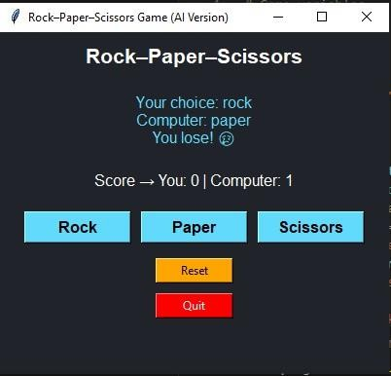
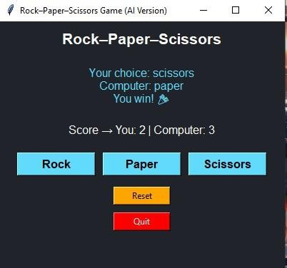

RESULTS AND FUTURE ENHANCEMENT
Result:
The system successfully allows continuous gameplay with a real-time scoreboard and a simple AI model that predicts the user’s next move. The GUI provides an easy and interactive gaming experience.

Future Enhancement:
- Integrate deep learning models for more advanced move prediction.
- Add sound effects and animations.
- Enable multiplayer online mode.
- Store user history for long-term learning.

Git Hub Link of the project and report | https://github.com/Devesh-1406/AI-mini-project-

REFERENCES

- Reference
  - https://docs.python.org/3/library/random.html
  - https://docs.python.org/3/library/tkinter.html
  - https://realpython.com/python-gui-tkinter/
  - https://www.geeksforgeeks.org/python-tkinter-tutorial/
  - https://www.programiz.com/python-programming/examples

